 | EUROPEAN COMMISSION  DIRECTORATE-GENERAL  INFORMATICS  Information Systems Directorate

European Commission
CIPADMIN Use Case Specification:
UC0010 - eTrustEx Admin Console - Manage Party

Date: | 31/01/2017
Version: | 2.001
Authors: | Anamaria BATRINU
Revised by: | Sandro D'ORAZIO, Maarten DANIELS
Approved by:
Public:
Reference Number:
TABLE OF CONTENTS
1. Use-Case Description 8
1.1. Primary Actor 8
1.2. Definitions, Acronyms and Abbreviations 9
1.3. References 9
1.4. Context Diagram 10
1.4.1. CIPA Administration Console 10
1.4.2. Manage Party module 10
2. Flow of events 11
2.1. Basic creation flow 11
2.1.1. User selects the Create Party menu action 11
2.1.2. System displays the "Create Party" page 11
2.1.3. User enters information 12
2.1.4. System creates the Party 14
2.1.5. System notifies the interested parties 14
2.1.6. System logs the creation and notification 14
2.1.7. System notifies user of creation success 14
2.1.8. User acknowledges the creation 14
2.1.9. The System redisplays the saved party in view mode 14
2.1.10. The basic creation flow ends. 14
2.2. Basic Search Flow 14
2.2.1. User selects the Search Party menu action 14
2.2.2. System displays the "Search Party" page 15
2.2.3. User enters the search criteria 15
2.2.4. System searches the parties 15
2.2.5. System displays the parties found 15
2.2.6. User views the result list 16
2.2.7. The basic search flow ends. 16
2.3. Basic Visualization Flow 16
2.3.1. At 2.2.6, User selects a Party in the list 16
2.3.2. System opens the "Party Visualization" page 16
2.3.3. User visualises the details of the party: 16
2.3.4. Visualization flow ends. 17
2.4. Basic Modification Flow 17
2.4.1. At 2.3.3., User chooses to edit a Party 17
2.4.2. The system opens the Party page in edit mode 17
2.4.3. User makes the changes 18
2.4.4. The system saves the modified Party 19
2.4.5. System notifies the interested parties 20
2.4.6. System logs the modification and notification 20
2.4.7. System notifies user of modification success 20
2.4.8. User acknowledges the modification 20
2.4.9. System redisplays the Party in view mode 20
2.4.10. The Modification flow ends. 20
2.5. Basic Deletion Flow 20
2.5.1. At 2.3.3., User chooses to delete a Party 20
2.5.2. System asks for deletion confirmation 20
2.5.3. User confirms the deletion 20
2.5.4. The system deletes the party 21
2.5.5. System notifies the interested parties 21
2.5.6. System logs the deletion and notification 21
2.5.7. System notifies user of deletion success 22
2.5.8. User acknowledges the deletion 22
2.5.9. The Deletion Flow ends. 22
2.6. Alternative Flows 22
2.6.1. AC1: at step 2.1.3., User chooses Cancel option 22
2.6.2. AC2: at step 2.1.3, User chooses Clear option 22
2.6.3. AC3: at step 2.1.4.(2), Business Rules are not verified 22
2.6.4. AC4: at steps 2.7.1(5), 2.7.2(5) or 2.7.3(5), Business Rules are not verified 22
2.6.5. A1: at steps 2.3.2, 2.4.2 and 2.5.2 the party to view, modify or delete does not pertain to the current business domain: 22
2.6.6. AM1: at step 2.4.2., the user is not authorized for modification 22
2.6.7. AM2: at step 2.4.3, User chooses Cancel option 22
2.6.8. AM3: at step 2.4.3, User chooses Reset option 23
2.6.9. AM4: at step 2.4.4., Business Rules are not verified 23
2.6.10. AD1: at step 2.5.2., Business Rules are not verified 23
2.6.11. AS1: At step (9) of Subflow S1, the System cannot process the certificate or extract the required data 23
2.7. Subflows 23
2.7.1. S1: at step 2.1.3., User wants to manage party certificates 23
2.7.2. S2: At step (6) of Subflow S1, User wants to delete a certificate 24
2.7.3. S3: At step (6) of Subflow S1, User wants to change the certificate information 25
2.7.4. S4: At step 2.4.3., User wants to change the password of the party credentials 25
2.8. Exceptional Flows 26
2.8.1. E1: at steps 2.1.1, 2.2.1, 2.3.1, 2.4.1 and 2.5.1 and subflows S1, S2 and S3 user is not authorized for the operation 26
2.8.2. E2: at steps 2.1.5, 2.4.5 and 2.5.5 a technical error occurs 26
3. Special Requirements 26
3.1. Interface(s) with other Systems 26
3.2. Security Requirements 26
3.3. Other Special Requirement 26
4. Preconditions 26
5. Post conditions 26
6. Additional Information 27
6.1. Includes 27
6.2. Extends 27
6.3. Event Notification Mappings 27
7. Mock-up screens 28
7.1. "Create Party" page 28
7.2. "Search Party" page 29
7.3. "View Party" page 29
7.4. "Edit Party" page 30
7.5. "Delete Party" page 31
7.6. "Manage party certificates" popup 31
7.7. "Edit certificate" popup 33
7.8. "Delete Certificate" Confirmation 34
7.9. View Party Certificates 34

Document History

Version | Date | Comment | Modified Pages
0.001 | 23/09/2013 | First draft | All
0.002 | 03/04/2014 | Changes relating to introducing business domain field in the database: mock-ups and business rules changes | Where needed
0.003 | 09/04/2014 | Changes mostly related to using consistency regarding mock-up buttons and their functionality. Updated Search business rules. Added Party and Interchange Agreement definitions. | Where needed
0.004 | 10/06/2014 | Update business rules and changed search screen | Where needed.
0.005 | 17/07/2014 | CBO users are allowed to create, view and modify certificate data | Where needed
0.006 | 25/08/2014 | Rule UC10_BR33 "CBO can modify identifiers associated to the party by only being able to change the identifier value in the list, not the identifier type" has been removed.
0.007 | 27/08/2014 | UC10_BR25 updated
0.008 | 17/09/2014 | Updated UC10_BR14  Added UC10_BR15 (min field length = 2 chars)
0.009 | 14/10/2014 | Maximum field size changed from 250 to 255 characters. Encoded data in the party certificate is allowed a maximum size of 4000 characters.  All certificate fields can be modified when editing a certificate (some were read-only).  Small mock-up updates
0.010 | 15/10/2014 | Removed specific messages (quoted ones) to allow more flexibility.
1.000 | 27/10/2014 | Adapted business rules to take into account multiple CBOs per business domain. | Where needed
1.001 | 30/10/2014 | UC10_BR29, UC10_BR30 and UC10_BR32 are expressing the same business rule. Keeping only one rule: UC10_BR30.
1.002 | 03/11/2014 | Added logging of user actions (CIPADMIN-279)  Updated screen labels (CIPADMIN-243) | Where needed
1.003 | 24/11/2014 | CIPADMIN-259 Certificate History for a Party  CIPADMIN-203 Import Certificate | Where needed
1.004 | 11/12/2014 | CIPADMIN-267: Support user role  Diagrams update
1.005 | 19/01/2015 | CIPADMIN-264: Ordered lists on screens | Where needed
1.006 | 20/03/2015 | CIPADMIN-322: Display the schemeIDs as BE:VAT instead of BE_VAT | Where needed
1.007 | 20/05/2015 | ETRUSTEX-738: added flag 'NaturalPerson' | Sections: Basic creation flow, Basic Search Flow, Mock-up screens
1.008 | 21/05/2015 | CIPADMIN-178: password strength | Sections: Basic creation flow, Basic Modification Flow
1.009 | 28/05/2015 | ETRUSTEX-1004: send notification configurations when creation, update or delete operations are executed. | Sections: Basic creation flow, Basic Modification Flow, Basic Deletion Flow
1.010 | 25/05/2016 | ETRUSTEX-1378: Added Is Third Party criteria to the search screen and flow (to facilitate the party search from the interchange agreement screen) | Sections: Basic Search Flow, "Search Party" page
1.011 | 26/07/2016 | ETRUSTEX-1559: The party role associations as well as the party agreement and party agreement transaction associations will be delete with the party if validation succeeds. Same for event notification configurations, metadata or endpoint configurations. Enpoint configurations can be deleted if there is no message routing information corresponding to them. LBO user access rights for the concerned party are also removed. | Section Basic Deletion Flow
1.012 | 27/07/2016 | ETRUSTEX-1509: Simplified the rules introduced with ETRUSTEX-1520 (old CIPADMIN-178) | Sections: Basic creation flow, Basic Modification Flow
1.013 | 19/08/2016 | ETRUSTEX-1586: Setting credentials type when saving parties and deleting party credentials when party is deleted. | Sections: Basic creation flow, Basic Modification Flow, Basic Deletion Flow
1.014 | 02/09/2016 | ETRUSTEX-1595: Allowing CBO to edit required signature and encrypted password flags for party credentials. | Basic creation flow, Basic Modification Flow  Screens: creation and modification (only the notes on the screens have been modified)
1.015 | 26/10/2016 | ETRUSTEX-1392
1.016 | 07/11/2016 | ETRUSTEX-2024: enabling evidence generation
1.017 | 20/12/2016 | Specified that event notification will not be generated for the ICA automatically created when evidence generation is enabled.
1.018 | 23/12/2016 | When enabling the evidence generation, if the party has no delegated parties the credentials become mandatory. | BR70 and BR71
2.000 | 16/01/2017 | ETRUSTEX-1937: Reorganizing CIPAdmin user roles
2.001 | 31/01/2017 | ETRUSTEX-2055 | Section 5.3 Event Notification Mappings
2.002 | 09/06/2017 | ETRUSTEX-2983 | Updated UC10_BR12
2.003 | 24/10/2017 | ETRUSTEX-3858 | Removed Evidence Generation specifications and updated mockup screens

Use-Case Description
This use case depicts the sequence of actions that a user needs in order to create a Party. The document also describes the management actions that correspond to a created Party, such as Update, Delete, View and Search.
The "Party Management" service is exposed on the CIPAdmin module of e-Trustex platform.
In the remainder of the document the CIPADMIN application will be referred to as the System.

Primary Actor
A human user can access the Manage Party feature via CIPAdmin interface. For detailed user access rights on each feature option, please see UC 0100 - eTrustEx Admin Console - Authenticate and Authorise User, section 6.3 User Access Rights.
In the remainder of the document, the user will be referred to as User or by his/her role, in those cases where role specific rules apply.

Definitions, Acronyms and Abbreviations
Acronym, Abbreviation or Definition | Explanation
CIPA | Common Infrastructure for Public Administrations
CIPADMIN | CIPA AdminConsole
ADM | A user having General Administrator role. The General Administrator is the Administrator of the CIPAdmin application.
CBO | A user having Central Business Owner role. The Central Business Owner is responsible for the organization and operation of a business domain and uses CIPA in his business context.
Party | Usually an organisation using the platform to exchange business documents.
ICA | Interchange Agreement (a logical communication channel which enables communication between two parties).
UC(s) | Use Case(s)

References
Ref. | Reference | Title / description | Version | Date
[R1]

Context Diagram

CIPA Administration Console
The diagram below depicts all the Services available on the CIPA Administration Console for e-TrustEx platform. Depending on the user role, only a subset of those services is exposed on the e-TrustEx Administration Console home page.
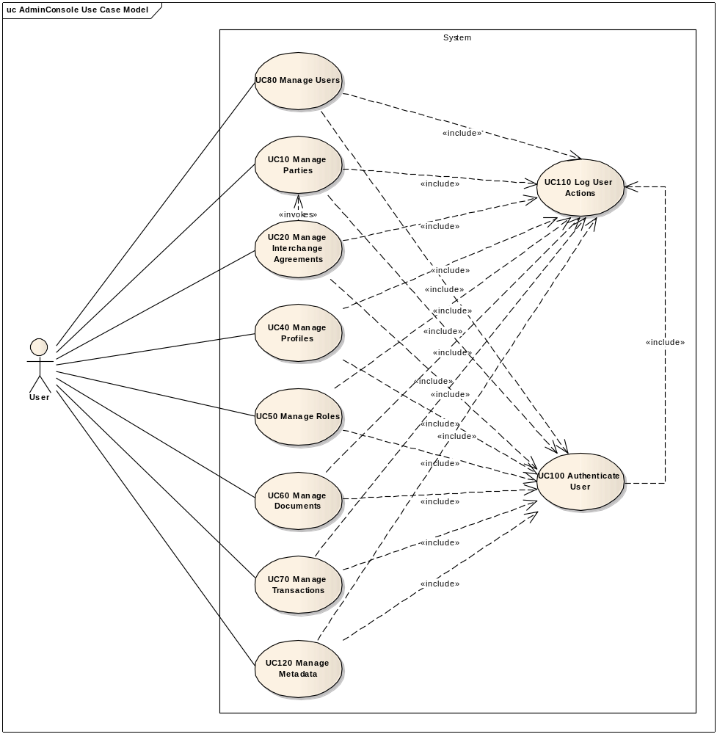

Manage Party module
The diagram below depicts the services that will be available for the first iteration of the Administration Console.
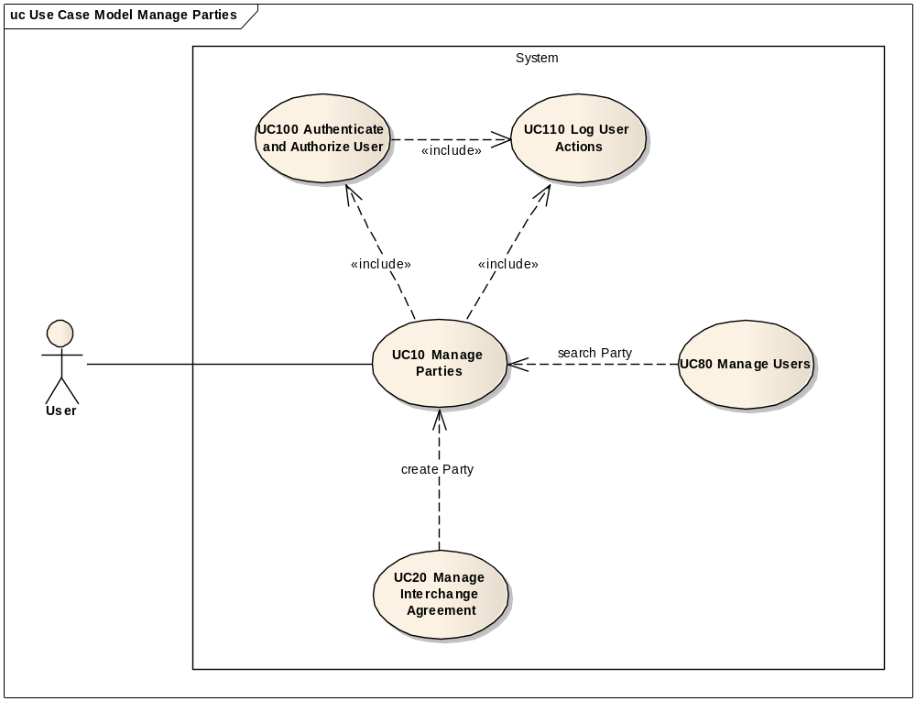

Flow of events
The conventions described in User Interface Generic Conventions document must be applied.

Basic creation flow
ID | Description
UC010_BR57 | User needs to have the correct access rights in order to access this feature. Please see UC 0100 - eTrustEx Admin Console - Authenticate and Authorise User, section 6.3 User Access Rights for more information.

User selects the Create Party menu action
The User selects the Create option of the Party menu of the e-TrustEx Administration Console home (Business Configuration > Party > Create).

System displays the "Create Party" page
System displays the 'Create Party' page as described in paragraph 7.1."Create Party" page:
- System retrieves all identifier types (e.g. EAN, GLN etc.) and populates a list with the identifiers' scheme ids. Technical note: these values can be found in the IdentifierIssuingAgency enum type, the scheme id will be shown to the user, while the enum field will be saved to the System's database.
- System defaults the party business domain to the currently selected user business domain
- System defaults the value of "Is 3rd party (Service Provider)" field to "No"
- System defaults the value of "Is natural person" field to "No"

- System does not show the "Is 3rd party (Service Provider)" field for users having LBO role

- System does not show the Manage Party Certificates option for users having LBO role
- System defaults the "Encrypted password" to "Yes"
- System defaults "Required signature" to "No"
- System does not show "Required Signature" and "Encrypted Password" flags for users having LBO role
- The lists present on the page shall be ascendant in alphabetical order ignoring case

User enters information
ID | Description
UC10_BR01 | "Party Name" is mandatory.
UC10_BR02 | Party name must be unique per business domain (to consider the application business domain)
UC10_BR03 | "Is 3rd Party" is set to "No" by default.
UC10_BR58 | "Is natural person" is set to "No" by default.
UC10_BR04 | For users having LBO role, "Is 3rd Party" option is not visible, thus always "No".
UC10_BR05 | "Username", "password" and "password confirmation" are mandatory if "Is 3rd Party" is set to "Yes" (for users having ADM or CBO role).  "Username", "password" and "password confirmation" are optional for users having LBO role, case in which a warning is displayed in the credentials section: "Please be aware that a party without credentials will have to connect to the System via a Service Provider / Third Party."
UC10_BR59 | It is recommended that the passwords fields follow the below guidelines:  - Length: minimum length of 10 characters  - Complexity – minimum 3 of the following:  - At least one lowercase alphabetic character (a-z)  - At least one uppercase alphabetic character (A-Z)  - At least one digit (0-9)  - At least one special character  These guidelines are displayed as information at the top of Credentials Section in the screen.  This business rule has informative purpose and does not impose the password recommendations to the user, thus the system being able to save the record even if the user does not follow the guidelines.
UC10_BR06 | The required signature and password encrypted flags will be set to false and respectively true by default in the screen. These fields are only visible and modifiable for users having ADM or CBO role.
UC10_BR07 | User can associate one or more identifiers to the party.  User can add one identifier value per identifier scheme id. E.g.: there will not be two VAT values identifying the same party.  The identifier must be unique per business domain. E.g.: there shall be no two parties pertaining to same business domain and having the same VAT number.  In case the selected business domain is eProcurement, a warning is displayed in the identifiers section: "Please be aware that a Party with no LEF id cannot be used in an interchange agreement for eProcurement business domain".
UC10_BR08 | At least one party identifier must be provided.
UC10_BR09 | The "Password" and "Confirm password" fields must contain the same value. If not, user is notified about the mismatching passwords.
UC10_BR10 | Filling in an identifier scheme id and its corresponding value shall give the user the possibility to fill in another identifier type and value.
UC10_BR11 | Party Certificate data can be imported only by users having ADM or CBO role.
UC10_BR49 | A Party can have more than one certificate, as certificates have different usages. However only one active certificate per usage is allowed at a given time.
UC10_BR12 | The Credentials must be unique among Credentials of type PARTY belonging to the same business domain.
UC10_BR61 | When saving party credentials, the system will automatically set the credentials type to PARTY. Note that only credentials of type PARTY should be linked to a party.
UC10_BR13 | The fields must be at most 255 characters.
UC10_BR14 | Leading and trailing spaces must not be part of the saved fields nor taken into account for UC10_BR13 and UC10_BR15. This rule does not apply for password fields.
UC10_BR15 | The fields must be at least 2 characters.

- The User fills in the party information:
  - The main information section:
    - Party name
    - Optionally, manages party certificates (see subflow S1): ADM/CBO users can import new party certificates, change certificate usage, the active and revoked status of a certificate or delete a certificate.
    - The 3rd party flag: Yes/No – users having ADM or CBO role only
    - The natural person flag: Yes/No
  - The credentials section:
    - Fills in party credentials (username, password and password confirmation)
    - Marks if required signature or encrypted password should be used – ADM and CBO roles only
  - Identifiers section:
    - User adds one or more party identifiers by choosing the identifier scheme id and entering the identifier value
- User chooses the Save option.

System creates the Party
- The System validates the page according to the business rules.
- If any business rule is not verified, the system goes to alternate flow AC3.
- The system saves the Party and its associated entities (e.g.: certificates added, modified or deleted, credentials, identifiers etc.).

System notifies the interested parties
- System retrieves all parties that are configured to receive a business configuration notification for the business domain of the created party
- System builds a message with relevant party information (like party name, scheme and value of party identifiers)
- System makes the message available to all concerned parties via a JMS interface. This message will be then processed as described in the e-TrustEx use case UC1_016 Submit Event Notification.

System logs the creation and notification
- System logs the successful creation of the party, and for each certificate it logs if it has been created, updated or deleted (if an existing party certificate has not been changed or deleted, no log will be created for it) : include use case Log CIPAdmin User Actions
- System logs that notification of party creation has been sent. Note that the log shall include the id of the created party as well as the party ids of the parties to which the notification has been sent.

System notifies user of creation success

    - User acknowledges the creation

The System redisplays the saved party in view mode
- The System goes to step 2.3.2 in "2.3. Basic View Flow"

The basic creation flow ends.

Basic Search Flow
ID | Description
UC10_BR57 | User needs to have the correct access rights in order to access this feature. Please see UC 0100 - eTrustEx Admin Console - Authenticate and Authorise User, section 6.3 User Access Rights for more information.

User selects the Search Party menu action
The User selects the Search option of the Party menu of the e-TrustEx Administration Console home page (Business Configuration > Party > Search). User can also trigger this flow by using a party search button found on a different page. Note that particular conditions may apply when the search is called from another page (like title of the popup, preselected readonly fields etc.) as mentioned in the caller use case.

System displays the "Search Party" page
The System displays the search page as described in paragraph 7.2. "Search Party" page. The lists present in the search criteria shall be ascendant in alphabetical order ignoring case.

User enters the search criteria
- The User enters one or more search criteria. A search criterion left empty means the concerned field will not be taken into account. The user can search by:
  - Party name
  - Business domain
  - Party username (while credentials type is PARTY)
  - Identifier value
  - Third party flag
    - Yes = only third parties will be searched for
    - No = only parties that are not third parties will be searched for
    - no selection = criteria will not be taken into account when searching (both third parties and non third parties will be searched for)
- The User chooses the search option.

System searches the parties
ID | Description
UC10_BR16 | A field left empty or containing only spaces is not taken into account during the search.
UC10_BR17 | By entering an identifier value to search on, all identifiers types will be searched for the specified value.
UC10_BR18 | Character case is ignored.
UC10_BR19 | Trailing and leading spaces are ignored.
UC10_BR20 | Field value can contain a partial match.
UC60_BR21 | At least one search field should be filled in.
UC60_BR22 | If a single search field is filled in, it needs to contain at least 2 characters.
The system searches the parties that satisfy all entered criteria and pertain to the current business domain.

System displays the parties found
The system displays the list of parties corresponding to the search criteria, in ascendant alphabetical order ignoring case, showing the following information:
- Party name
- Business domain
- Is 3rd party
- Is natural person
- Party username
- Party identifiers

User views the result list
  - The User can by clicking on the value in the first column
    - view the details of a party (see 2.3. Basic Visualization Flow) if accessed via the main menu
    - select the party and return it to the caller page, if accessed from other pages as a popup window
  - The User can launch a new search

The basic search flow ends.

Basic Visualization Flow
ID | Description
UC010_BR57 | User needs to have the correct access rights in order to access this feature. Please see UC 0100 - eTrustEx Admin Console - Authenticate and Authorise User, section 6.3 User Access Rights for more information.

At 2.2.6, User selects a Party in the list
(Alternative: in case the party id is known, the user can enter the link in the browser following the pattern http://hostname:port/etrustex-admin-web/party/<partyId>/view.do, where partyId is the id of the party to view)

System opens the "Party Visualization" page
The System shows the Party visualization page as described in paragraph 7.3."View Party" page:
- System reads the data
- System loads data on screen
- All fields are protected
- "View Certificates" option is displayed
- "Cancel", "Edit" and "Delete" buttons are made available

User visualises the details of the party:
- User can return to the result list by choosing "Cancel", the view flow ends and basic search flow restarts at 2.2.5
- User can view the party certificates by choosing the option View Party Certificates
  - System displays the certificates popup as in section 7.9. View Party Certificates
  - User views all the party certificates in a list without the option to modify or delete them. The certificate information that is shown:
    - Certificate serial number
    - Validity start date
    - Validity end date
    - Certificate usage
    - Creation user
    - Active status
    - Revoked status
  - By choosing Cancel or OK options, user will be return to the party view screen
- User can choose to edit or to delete a party (see 2.4 Basic Modification Flow and 2.5. Basic Deletion Flow)

Visualization flow ends.

Basic Modification Flow
ID | Description
UC010_BR57 | User needs to have the correct access rights in order to access this feature. Please see UC 0100 - eTrustEx Admin Console - Authenticate and Authorise User, section 6.3 User Access Rights for more information.

At 2.3.3., User chooses to edit a Party
(Alternative: in case the party id is known, the user can enter the link in the browser following the pattern http://hostname:port/etrustex-admin-web/party/<partyId>/edit.do, where partyId is the id of the party to edit)

The system opens the Party page in edit mode
ID | Description
UC10_BR23 | LBO can modify only parties pertaining to his/her business domain and that have been created by himself/herself or another LBO acting in behalf of the same party as the user.
UC10_BR24 | A user can modify only parties pertaining to his/her business domain.
UC10_BR25 | "Party Name" is protected.
UC10_BR26 | Party Business Domain cannot be changed. If it is not correct, then the party needs to be deleted, and created in the desired business domain.
UC10_BR27 | "Is 3rd Party" is not visible (thus not modifiable) for LBO.
UC10_BR67 | The required signature and password encrypted flags are only visible and modifiable for users having ADM or CBO role.
UC10_BR28 | Existing "Username" associated with the party cannot be changed (protected).
UC10_BR30 | By default, if party credentials already exist, the password corresponding to them shall not be changed. An option to change the password is made available to the user. When using this option, if the user leaves empty both fields password and confirm password, the old password shall not be modified.
UC10_BR59 | It is recommended that the passwords fields follow the below guidelines:  - Length: minimum length of 10 characters  - Complexity – minimum 3 of the following:  - At least one lowercase alphabetic character (a-z)  - At least one uppercase alphabetic character (A-Z)  - At least one digit (0-9)  - At least one special character  These guidelines are displayed as information at the top of Credentials Section in the screen.  This business rule has informative purpose and does not impose the password recommendations to the user, thus the system being able to save the record even if the user does not follow the guidelines.
UC10_BR09 | The "(Enter new) Password" and "Confirm password" fields must contain the same value. If not, user is notified about the mismatching passwords.
UC10_BR10 | Filling in an identifier scheme id and its corresponding value shall give the user the possibility to fill in another identifier scheme id and value.
UC10_BR11 | Party Certificate data can be imported only by users having ADM or CBO role.
UC10_BR49 | A Party can have more than one certificate, as certificates have different usages. However only one active certificate per usage is allowed at a given time.
UC10_BR12 | The Credentials must be unique among Credentials of type PARTY belonging to the same business domain.
UC10_BR61 | When saving party credentials, the system will automatically set the credentials type to PARTY. Note that only credentials of type PARTY should be linked to a party.
UC10_BR13 | The fields must be at most 255 characters.
UC10_BR14 | Leading and trailing spaces must not be part of the saved fields nor taken into account for UC10_BR13 and UC10_BR15. This rule does not apply for password fields.
UC10_BR15 | The fields must be at least 2 characters.

- The system verifies the user rights for the selected party. If no rights, the system goes to alternate flow AM1.
- System loads the party data
- The System displays the Party page in edit mode as described in paragraph 7.4."Edit Party" page
- The lists present on the page shall be ascendant in alphabetical order ignoring case
- "Cancel", "Reset" and "Save" options are present.

User makes the changes
- User makes the desired changes:
  - For managing party certificates see subflow S1.
  - For changing party credentials see subflow S4.
- User chooses the save option

The system saves the modified Party
ID | Description
UC10_BR31 | Changing "Is 3rd Party" value from "Yes" to "No", will not be allowed if there are parties that use the current party as a third party.  A message will inform the user that "There are parties using this service provider, there for you cannot remove the 3rd party status."
UC10_BR49 | A Party can have more than one certificate, as certificates have different usages. However only one active certificate per usage is allowed at a given time.
UC10_BR05 | "Username", "password" and "password confirmation" are mandatory if "Is 3rd Party" is changed to "Yes", and there was no username associated to the party.
UC10_BR30 | By default, if party credentials already exist, the password corresponding to them shall not be changed. An option to change the password is made available to the user.
UC10_BR09 | The "Password" and "Confirm password" fields must contain the same value. If not, user is notified about the mismatching passwords.
UC10_BR06 | The required signature and password encrypted flags are only visible and modifiable for users having ADM or CBO role.
UC10_BR07 | User can associate one or more identifiers to the party.  User can add one identifier value per identifier scheme id. e.g.: there will not be two VAT values identifying the same party.  The identifier must be unique per business domain. E.g.: there shall be no two parties p ertaining to same business domain and having the same VAT number.  In case the selected business domain is eProcurement, a warning is displayed in the identifiers section: "Please be aware that a Party with no LEF id cannot be used in an interchange agreement for eProcurement business domain".
UC10_BR12 | The Credentials must be unique among Credentials of type PARTY belonging to the same business domain.
UC10_BR13 | The fields must be at most 255 characters.
UC10_BR14 | Leading and trailing spaces must not be part of the saved fields nor taken into account for UC10_BR13 and UC10_BR15. This rule does not apply for password fields.
UC10_BR15 | The fields must be at least 2 characters.
- The system validates the page according to the business rules.
- If any business rule is not verified, the system goes to alternate flow AM4.
- The system saves the Party, and the associated entities (e.g. certificates added, modified or deleted, credentials, identifiers, roles, etc.).

System notifies the interested parties
- System retrieves all parties that are configured to receive a business configuration notification for the business domain of the modified party
- System builds a message with relevant party information before and after the modification (like party name, scheme and value of party identifiers)
- System makes the message available to all concerned parties via a JMS interface. This message will be then processed as described in the e-TrustEx use case UC1_016 Submit Event Notification.

System logs the modification and notification
- System logs the successful modification, and for each certificate it logs if it has been created, updated or deleted (if an existing party certificate has not been changed or deleted, no log will be created for it): include use case Log CIPAdmin User Actions
- System logs that notification of party modification has been sent. Note that the log shall include the id of the modified party as well as the party ids of the parties to which the notification has been sent.

System notifies user of modification success

User acknowledges the modification

System redisplays the Party in view mode
The system redisplays the party in visualization mode as in paragraph 7.3."View Party" page.

The Modification flow ends.

Basic Deletion Flow
ID | Description
UC010_BR57 | User needs to have the correct access rights in order to access this feature. Please see UC 0100 - eTrustEx Admin Console - Authenticate and Authorise User, section 6.3 User Access Rights for more information.

At 2.3.3., User chooses to delete a Party

System asks for deletion confirmation

User confirms the deletion
If user chooses to cancel the delete, he is returned to the visualization page

The system deletes the party
ID | Description
UC10_BR34 | LBO can delete only parties pertaining to his/her business domain and that have been created by himself/herself or another LBO acting in behalf of the same party as the user.
UC10_BR35 | A User can delete only parties pertaining to his/her business domain.
UC10_BR36 | Parties that are used in an Interchange Agreement cannot be deleted. If there is an Interchange Agreement involving the party, and based on which messages were exchanged, the party cannot be deleted. User is notified if he/she attempts to delete such party.
UC10_BR37 | Only parties pertaining to the current business domain can be deleted.
UC10_BR60 | Parties that are used in an Endpoint Configuration (ETR_TB_ENDPOINT) for which there is a message routing record (ETR_TB_MESSAGE_ROUTING) cannot be deleted.

- The system verifies the business rules. If not verified, the system goes to alternate flow AD1.
- System retains temporary party information to use in the notification process
- System deletes the party, all certificates belonging to it and the associated credentials. The Party Role associations (ETR_TB_PARTY_ROLE), as well as the Party Agreement (ETR_TB_PARTYAGREEMENT) and Party Agreement Transaction (ETR_TB_PARTYAGREEMENT_TRAN) associations are also deleted. If there are event notifications (CPA_TB_EVT_NOTIF), metadata (ETR_TB_METADATA) or endpoints (ETR_TB_ENDPOINT) configured fore the party, these records are also deleted. User access rigths (CPA_TB_USER_RIGHTS) corresponding to the party must also be removed. The interchange agreements in which the party is involved are also deleted (note the UC10_BR36 ensures none of them were yet used in exchanging messages).

System notifies the interested parties
- System retrieves all parties that are configured to receive a business configuration notification for the business domain of the deleted party
- System builds a message with relevant party information (like party name, scheme and value of party identifiers) that has been retained before the deletion
- System makes the message available to all concerned parties via a JMS interface. This message will be then processed as described in the e-TrustEx use case UC1_016 Submit Event Notification.

System logs the deletion and notification
- System logs the successful deletion of the party and of each of the party certificates: include use case Log CIPAdmin User Actions. System also logs the deletion of any additional records related to that party (like metadata, event configuration notification, routing endpoints etc.)
- System logs that notification of party deletion has been sent. Note that the log shall include the id and name of the deleted party as well as the party ids of the parties to which the notification has been sent.

System notifies user of deletion success

User acknowledges the deletion

The Deletion Flow ends.

Alternative Flows

AC1: at step 2.1.3., User chooses Cancel option
- System disregards all information provided by User
- System closes the page
- System redirects the user to CIPAdmin home page

AC2: at step 2.1.3, User chooses Clear option
- Systems disregards all information provided by the user
- Alternate flow ends and basic creation flow restarts at 2.1.2.

AC3: at step 2.1.4.(2), Business Rules are not verified
- System logs the error: include use case Log CIPAdmin User Actions
- The system informs the User about the error
- Alternate flow ends and basic creation flow restarts at 2.1.3.

AC4: at steps 2.7.1(5), 2.7.2(5) or 2.7.3(5), Business Rules are not verified
- System logs the error: include use case Log CIPAdmin User Actions
- The system informs the User about the error
- Alternate flow ends and subflow restarts at 2.7.1.(3), 2.7.2.(3) or 2.7.3.(3) respectively.

A1: at steps 2.3.2, 2.4.2 and 2.5.2 the party to view, modify or delete does not pertain to the current business domain:
- System logs the error: include use case Log CIPAdmin User Actions
- System informs user
- System redirects the user to the home page
- Alternate flow ends

AM1: at step 2.4.2., the user is not authorized for modification
- System logs the error: include use case Log CIPAdmin User Actions
- The system notifies the user that he/she is not authorized to modify the Party
- User acknowledges the notification
- Alternate flow ends and basic flow restarts at 2.3.3 (visualization page).

AM2: at step 2.4.3, User chooses Cancel option
- System disregards all information provided by User
- System closes the page
- Alternate flow ends and basic flow restarts at 2.3.2 (visualization page).

AM3: at step 2.4.3, User chooses Reset option
- Systems disregards all information provided by the user
- Alternate flow ends and basic modification flow restarts at 2.4.2.

AM4: at step 2.4.4., Business Rules are not verified
- System logs the error: include use case Log CIPAdmin User Actions
- The system informs the User about the errors
- Alternate flow ends and basic modification flow restarts at 2.4.3.

AD1: at step 2.5.2., Business Rules are not verified
- System logs the error: include use case Log CIPAdmin User Actions
- The system notifies the user about the errors
- Alternate flow ends and basic flow restarts at 2.3.3 (visualization page).

AS1: At step (9) of Subflow S1, the System cannot process the certificate or extract the required data
- System logs the error: include use case Log CIPAdmin User Actions
- System notifies the user about the error
- Alternate flow ends and the subflow restarts at step (2)

Subflows

S1: at step 2.1.3., User wants to manage party certificates
ID | Description
UC010_BR57 | User needs to have the correct access rights in order to access this feature. Please see UC 0100 - eTrustEx Admin Console - Authenticate and Authorise User, section 6.3 User Access Rights for more information.
UC10_BR42 | "Usage" is mandatory.
UC10_BR47 | "Is Active" is mandatory.
UC10_BR48 | "Is Revoked" is mandatory.
UC10_BR49 | A Party can have more than one certificate, as certificates have different usages. However only one active certificate per usage is allowed at a given time.
UC10_BR51 | Revoked status shall not be changed from revoked to not revoked, as revoked is a permanent state.  Note: To avoid accidental revoking of the certificate, the application asks the user to confirm the certificate revocation.
UC10_BR52 | Certificate selection is mandatory.
UC10_BR53 | The uploaded certificate must be at most 100k in size.

- This subflow starts when user chooses to manage party certificates.
- The System displays 'Manage Party Certificates' page as described in paragraph 7.6. "Manage party certificates" popup
- User enters the certificate information:
  - selects the certificate location by using the provided search option
  - chooses the certificate usage
  - specifies the active state
  - specifies the revoked state
- User chooses Upload option
- System verifies the business rules
  - If any business rule is not verified, the system goes to alternate flow AC4.
- System processes the certificate, extracts the values corresponding to the certificate serial number, the validity start date and the validity end date and assigns them to the corresponding entity fields. The encrypted certificate information (base64) is also placed in the encoded data field. If error when processing/extracting certificate data, see AS1.
- System updates the certificate list in the Certificates section
  - User can delete certificates in the list (see subflow S2)
  - User can edit certificates in the list (see subflow S3)
- User can upload a new certificate by restarting from step (3)
- User chooses "OK".
  - If the user chooses "Cancel":
    - The entered/modified data is discarded
    - The subflow ends
- The system retains certificate(s) information that will be saved with the party
- Subflow ends

    - S2: At step (6) of Subflow S1, User wants to delete a certificate
ID | Description
UC010_BR57 | User needs to have the correct access rights in order to access this feature. Please see UC 0100 - eTrustEx Admin Console - Authenticate and Authorise User, section 6.3 User Access Rights for more information.
It is highly recommended to deactivate a certificate instead of deleting it. Deletion shall only be used if while configuring the party certificates the user has imported a wrong certificate.
This subflow starts when User chooses to delete a certificate associated to the party.
- User chooses the option delete on the line corresponding to the certificate to delete
- System displays a warning that lets the user know deletion of certificates is not recommended and asks for confirmation
- User confirms the deletion
- System removes the certificate from the list and continues from step (6) in Subflow S1

S3: At step (6) of Subflow S1, User wants to change the certificate information
ID | Description
UC10_BR57 | User needs to have the correct access rights in order to access this feature. Please see UC 0100 - eTrustEx Admin Console - Authenticate and Authorise User, section 6.3 User Access Rights for more information.
UC10_BR42 | "Usage" is mandatory.
UC10_BR47 | "Is Active" is mandatory.
UC10_BR48 | "Is Revoked" is mandatory.
UC10_BR50 | Only the certificate usage, the active and revoked flags can be modified for a certificate.
UC10_BR51 | Revoked status shall not be changed from revoked to not revoked, as revoked is a permanent state.  Note: To avoid accidental revoking of the certificate, the application asks the user to confirm the certificate revocation.

This subflow starts when User chooses to change a certificate associated to the party.
- User chooses the option edit on the line corresponding to the certificate to modify
- The System displays Edit Certificate' popup as described in paragraph 7.7. "Edit certificate" popup
- User modifies the certificate information
- User chooses "OK":
  - User chooses "Cancel":
    - The entered data is discarded
    - The subflow ends
- The system verifies the business rules
  - If any business rule is not verified, the system goes to alternate flow AC4.
- System updates the certificate in the list and continues from step (6) in Subflow S1

S4: At step 2.4.3., User wants to change the password of the party credentials
ID | Description
UC10_BR54 | "Enter new password" is mandatory.
UC10_BR55 | "Confirm new password" is mandatory.
UC10_BR56 | Both values of "Enter new password" and "Confirm new password" must be equal.

- This alternate flow starts when User chooses to change the password of the party user.
- The System displays 'Change Party' popup as described in paragraph 7.4. "Edit party" page
- User fills in the new password
- User confirms the new password
- User chooses "OK":
  - User chooses "Cancel":
    - The entered data is discarded
    - The subflow ends
- The system verifies the business rules
  - If any business rule is not verified, the system goes to alternate flow AC4.
- The system retains the new password
- Subflow ends

Exceptional Flows

E1: at steps 2.1.1, 2.2.1, 2.3.1, 2.4.1 and 2.5.1 and subflows S1, S2 and S3 user is not authorized for the operation
Include the steps in section 2.4.1 of Authenticate and Authorise User Use Case.

E2: at steps 2.1.5, 2.4.5 and 2.5.5 a technical error occurs
- The created party and all its subentities are disregarded (rollback)
- The user is informed about the error
- The use case ends

Special Requirements

Interface(s) with other Systems

Security Requirements

Other Special Requirement

Preconditions
- User must be registered user of CIPAdmin tool
- User must be logged in & successfully authenticated on the e-TrustEx Admin Console

Post conditions
- [Success] The Party has been successfully created/modified/deleted.
- [Failure] The System logs the failure reason and the context, the use case is aborted and the primary actor has been notified of the reasons.

Additional Information

Includes
- For operation authorization: UC 0100 - eTrustEx Admin Console - Authenticate and Authorise User
- For logging: UC 0110 - eTrustEx Admin Console - Log CIPAdmin User Actions
- For searching or visualizing a document: UC 0060 - eTrustEx Admin Console - Manage Document

Extends

Event Notification Mappings
EC-CommonAggregateComponents-2.1.xsd will be used for the party element.
The mappings are common to all Party Event Notifications, The sender will be eTrustEx and the receiver the event subscriber.
Table 6.3-1 Parent element xPath by Event contains information about the xPaths of the parent Party element for each of the three events. All information in its subelements is common for the events and will be described in Table 6.3-2 Common Party Information.
Table 6.3-1 Parent element xPath by Event
Event | xPath of parent element (the second table contains the relative paths to party information which is common for all event)
CreatePartyEventNotification | Event/CreatePartyEvent/Party
UpdatePartyEventNotification | Event/UpdatePartyEvent/FromParty/Party – referring to party information before the update.  Event/UpdatePartyEvent/ToParty/Party – referring to party information after the update.
DeletePartyEventNotification | Event/DeletePartyEvent/Party

Table 6.3-2 Common Party Information
Element (xPath) | Information
PartyIdentification/ID and PartyIdentification/ID/@schemeId | For each party identifier: the party identifier value and its scheme id.
PartyName/Name | The name of the party.
Person | The presence of this element means that the Party is a Natural Person (as per Natural Person flag). No value and no child element shall be specified.
ThirdPartyIndicator | Boolean value representing the third party flag.
PartyCredentials | This element and its children are only present when the party has credentials and the event subscriber has a public key in eTrustEx trustStore.
PartyCredentials/Username | Credentials username (encrypted with the event subscriber's public key)
PartyCredentials/Password and PartyCredentials/Password/@encrypted | Credentials password (encrypted with the event subscriber's public key) with encrypted attribute set to true.
PartyCredentials/PawsordEncrypted | Boolean value corresponding to PasswordEncrypted flag indicating if the password is encrypted before being hashed and stored in eTrustEx.
PartyCredentials/SignatureRequired | Boolean value corresponding to Signature Required flag
X509Certificate | The Party Certificate if any. This element is not present if no party certificate is present. If more certificates are present, the active certificate will be considered.

Mock-up screens

"Create Party" page
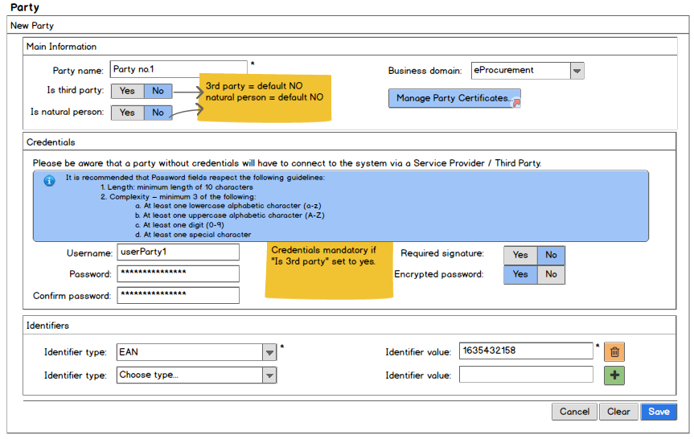

"Search Party" page
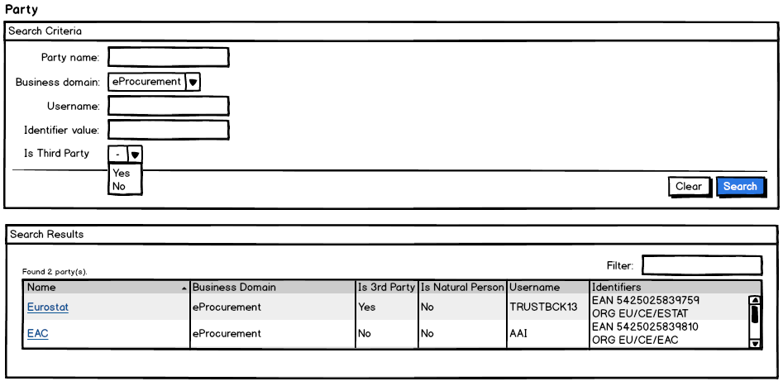

"View Party" page
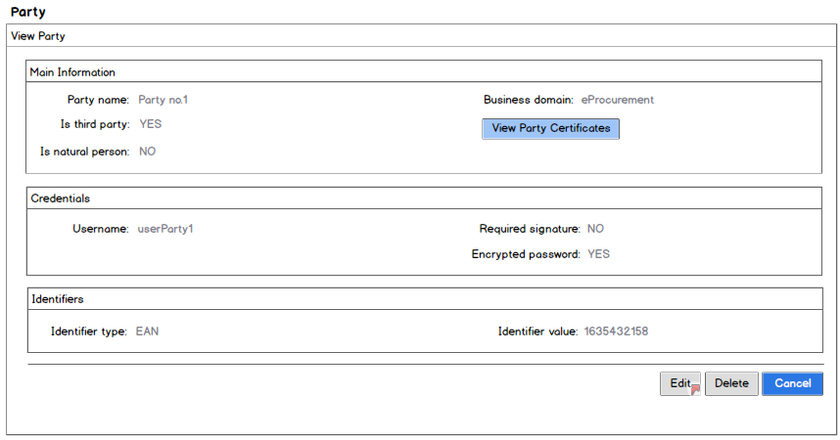

"Edit Party" page
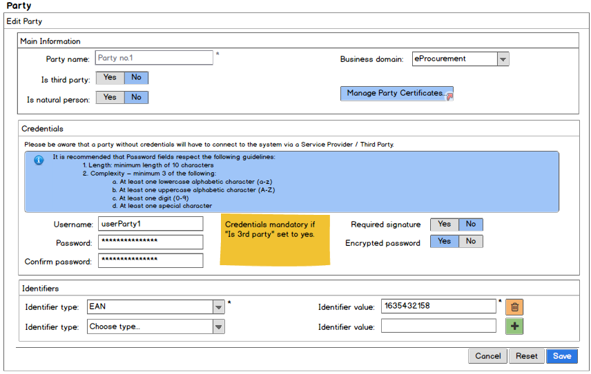
In case the party to be edited has credentials:
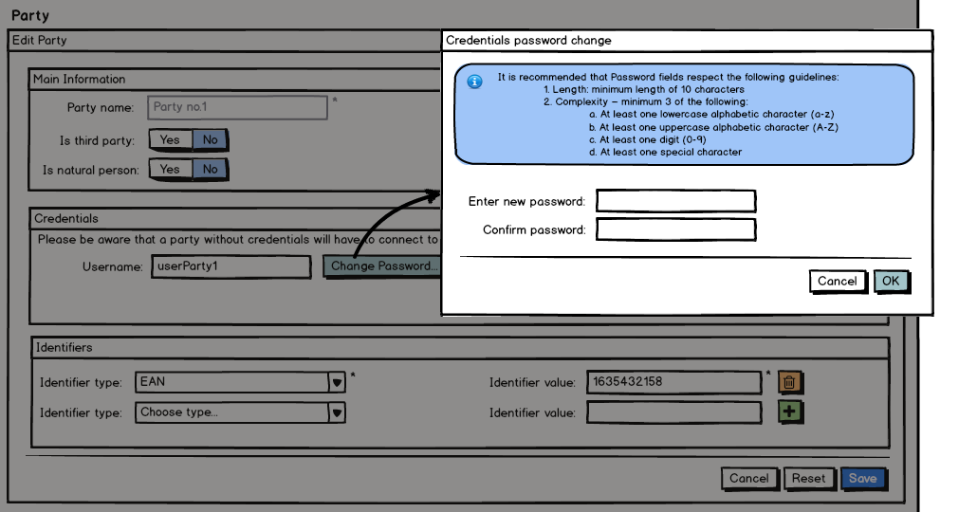

"Delete Party" page
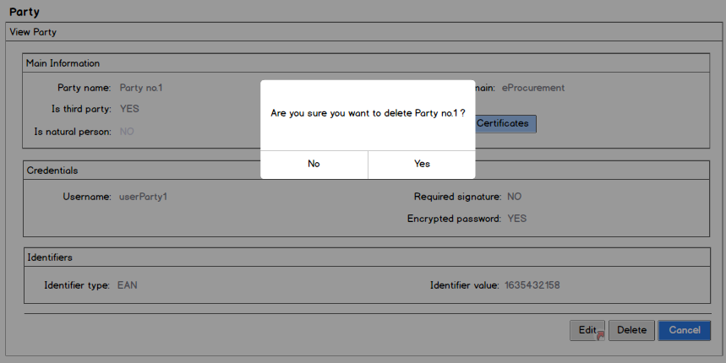

"Manage party certificates" popup
Manage Party Certificates 1- no existing party certificates
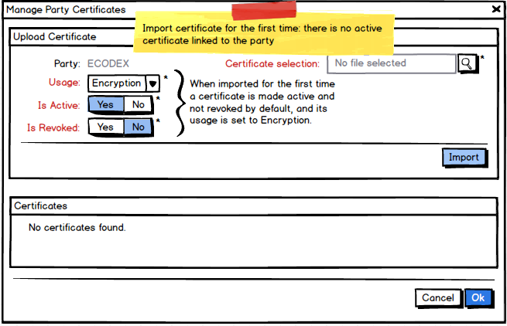
Manage Party Certificates 2 - certificates imported
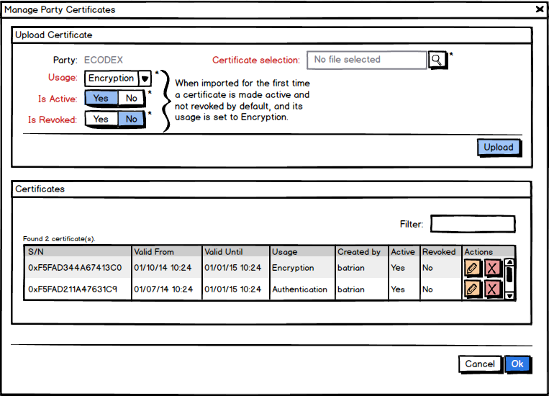
The Manage Party Certificates page consists of 2 sections:
- First section is used to upload a new certificate and set its usage, as well as to set the values of active and revoked flags. The system sets the values of the flags to active and not revoked by default.
- The second section is used to show the existing party certificates and the ones just imported in the shape of a list. The user is offered the possibility to perform actions like delete or edit on any of the party certificates by using the buttons in the last column.
The information shown for each certificate is:
  - Certificate serial number (extracted from the imported certificate)
  - Validity start date (extracted from the imported certificate)
  - Validity end date (extracted from the imported certificate)
  - Certificate usage (possible values: Encryption – corresponding value in database is KEY_ENCIPHERMENT)
  - Creation user
  - Active status
  - Revoked status
- The lists present on the page shall be ascendant in alphabetical order ignoring case

"Edit certificate" popup
Manage Party Certificates 3 - Edit Certificate Popup
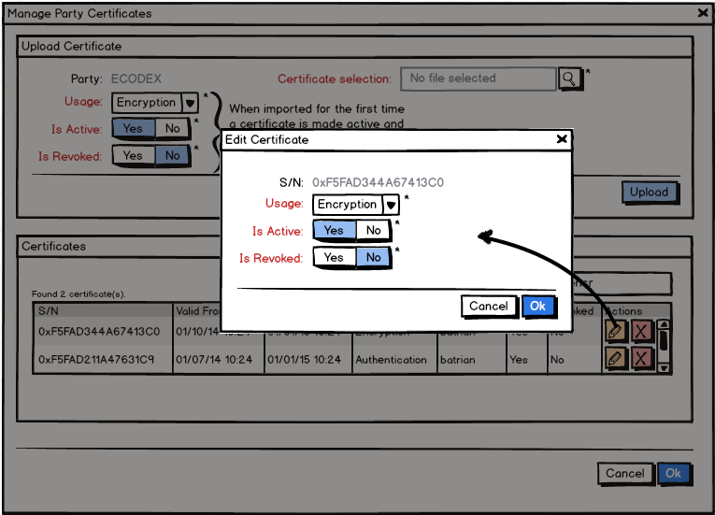
The lists present on the page shall be ascendant in alphabetical order ignoring case.

"Delete Certificate" Confirmation
Manage Party Certificates 4 - Delete Certificate Confirmation Popup
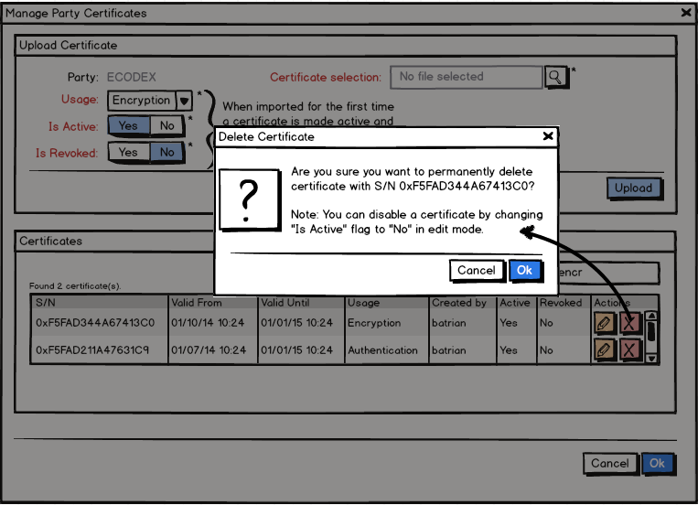

View Party Certificates
